**1.Write a C program using function that takes a character indicating a color as an input argument and displays the full color if it is present else prints the message that the color is not present. Here function doesn't return anything. Rainbow colours: R O Y G B I V = Red Orange Yellow Green Blue Indigo Violet.**

Program:

#include <stdio.h>

void colour(char c)

{

switch(c)

{

case 'r':

case 'R':

printf("Red");

break;

case 'o':

case 'O':

printf("Orange");

break;

case 'y':

case 'Y':

printf("Yellow");

break;

case 'g':

case 'G':

printf("Green");

break;

case 'b':

case 'B':

printf("Blue");

break;

case 'i':

case 'I':

printf("Indigo");

break;

case 'v':

case 'V':

printf("Violet");

break;

default:

printf("Colour is not present");

}

}

int main()

{

char c;

printf("Enter the colour code: ");

scanf("%c",&c);

colour(c);

return 0;

}

**OUTPUT:**

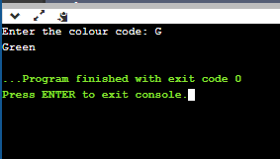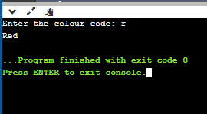

**2. Write a program in C to convert decimal number to binary number using the function.**

Program:

#include <stdio.h>

void bin(int n)

{

int arr[32];

int i = 0,j;

while (n > 0)

{

arr[i] = n % 2;

n = n / 2;

i++;

}

for (j = i - 1; j >= 0; j--)

printf("%d",arr[j]);

}

int main()

{

int n;

printf("Enter the decimal number: ");

scanf("%d",&n);

printf("The equivalent binary number is :");

bin(n);

return 0;

}

**OUTPUT:**

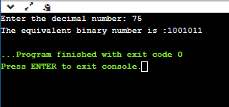

**3. Write a function to find if a given number is prime or not. Function takes number as input argument. It returns 1 if number is prime else return 0. Based on the return value, print the appropriate message in main function.**

Program:

#include <stdio.h>

int prime(int n)

{

int i,t=0;

for(i=2;i<=n/2;i++)

{

if(n%i==0)

{

t=1;

break;

}

}

if(t==1)

return 0;

else

return 1;

}

int main()

{

int n;

printf("Enter the number:");

scanf("%d",&n);

if(n==1)

printf("The number is neither prime nor composite");

else if(prime(n))

printf("The number is prime");

else

printf("The number is composite");

return 0;

}

**OUTPUT:**

**

**4.Write a program that takes the x-y coordinates of a point in the Cartesian plane. Write a function which takes as input the x-y coordinates and returns the quadrant in which it lies.**

Program:

#include <stdio.h>

int quad(int x,int y)

{

if(x>0)

{

if(y>0)

return 1;

else

return 4;

}

else

{

if(y>0)

return 2;

else

return 3;

}

}

int main()

{

int x,y;

printf("Enter the X-Coordinate: ");

scanf("%d",&x);

printf("Enter the Y-Coordinate: ");

scanf("%d",&y);

if(x==0 && y==0)

printf("The point %d,%d lies on the origin",x,y);

else if(x==0)

printf("The point %d,%d lies on the Y Axis",x,y);

else if(y==0)

printf("The point %d,%d lies on the X Axis",x,y);

else

printf("The quadrant in which point %d,%d lies is %d",x,y,quad(x,y));

return 0;

}

**OUTPUT:**

